Rheumatic fever is a sickness caused by a germ called Group A Streptococcus or Strep for short and can often cause sore throats and skin sores. If not treated with penicillin, the body’s germ defence system can get confused and attack your joints, heart, brain, and skin – This is called rheumatic fever.

Rheumatic fever can damage the valves inside your heart making them leak or not open properly – This is called rheumatic heart disease.

Your child will be offered a special heart scan called an echocardiogram (echo) to check their heart for rheumatic heart disease.

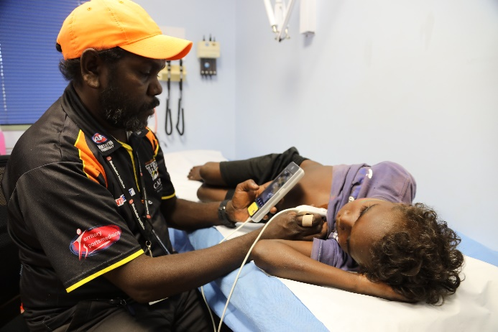
To check for rheumatic heart disease it is a quick and painless test.
- Gel will be placed on the chest of your child and an echo probe will take a picture of their heart
- If the echo is normal no further follow up will be needed
- If the echo is not normal, the Doctor will talk to the parents and the child on the same day

I consent for my child __________________________________, DOB: _ _ / _ _ / _ _ _ _ to have an echocardiogram to screen for Rheumatic Heart Disease.

Signed parent/guardian: _________________________________ Date: _ _ / _ _ / _ _ _ _

For educational purposes photographs may be taken during the screening. Your child’s modesty will be maintained. If you consent to photos being taken, please sign below.

Signed parent/guardian: _________________________________ Date: _ _ / _ _ / _ _ _ _

